Visiting zoo

After travelling to Poland and getting to know Polish students, making friends, they also visited Hungary in June. We invited them to the zoo in Sóstó, Nyíregyháza. We had a really great time.

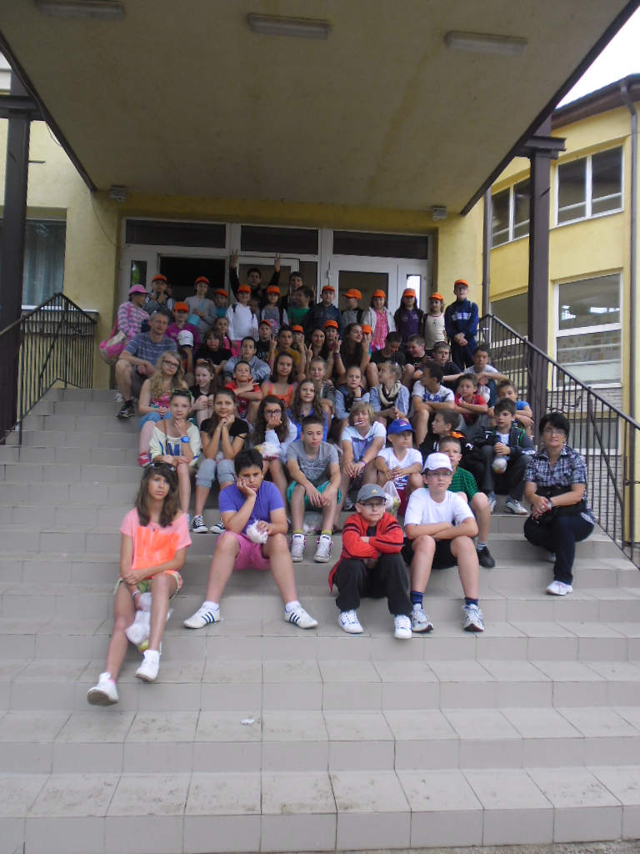
Before going to the zoo. Our picture together with Polish students and teachers.
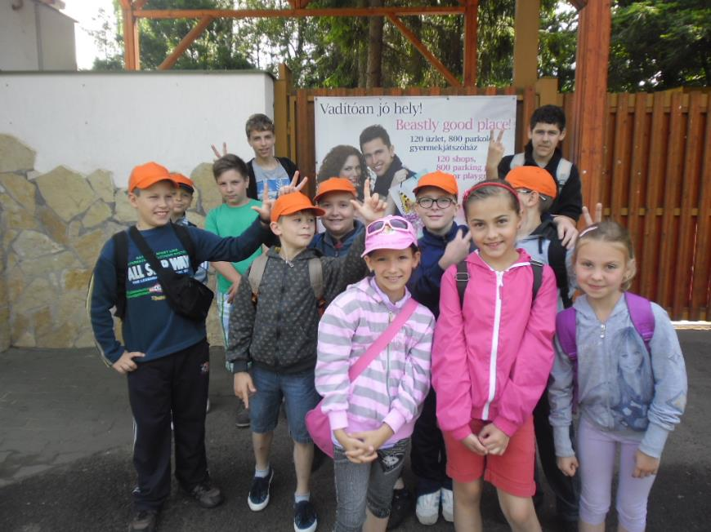
We are standing in front of the zoo. Waiting is never boring for us. We always have fun.
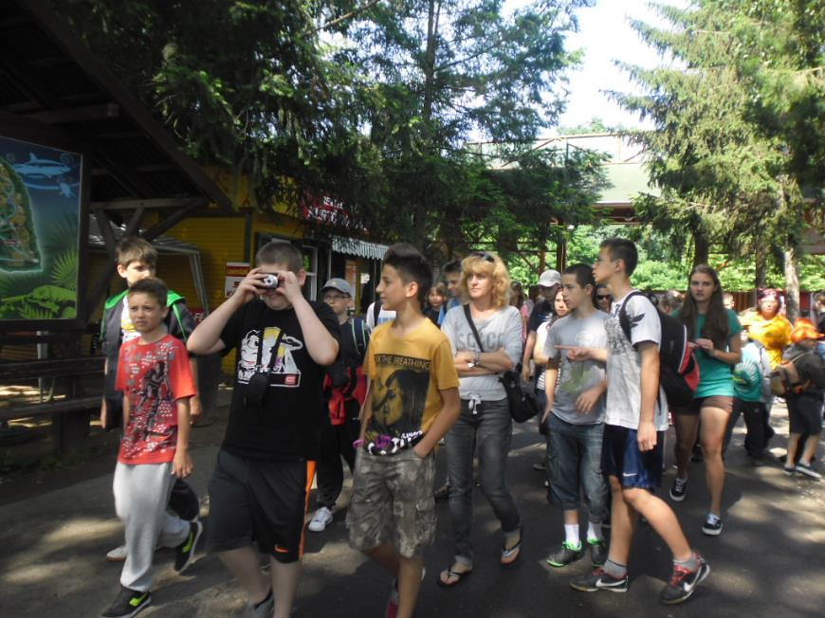
Our Polish friends couldn’t wait for watching the animals.
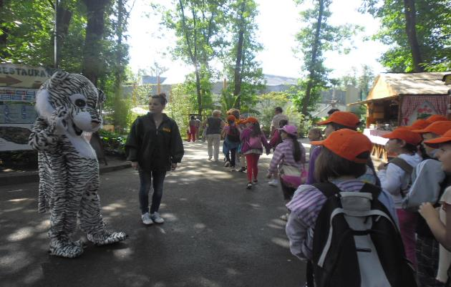
A tiger welcomed us happily. He was very funny.
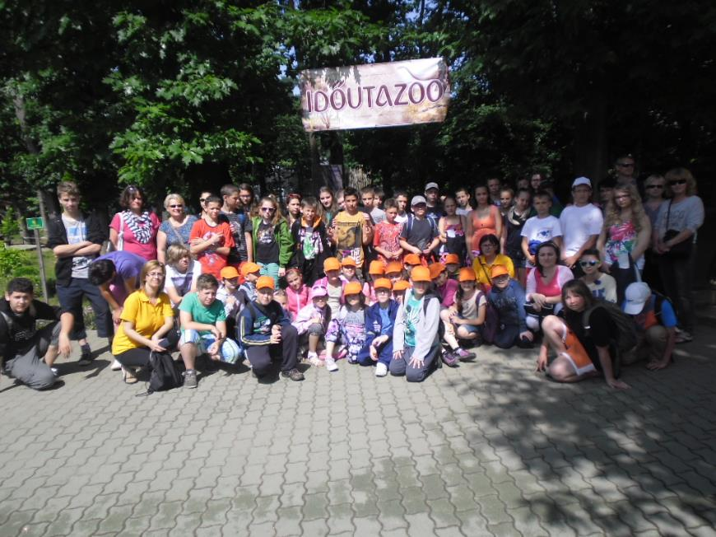
A photo under the title called ’Time travelling.’ We had a sunny day and we were ready to a new adventure. We were the ones with orange caps.

Our first place to visit was the Ocean World:

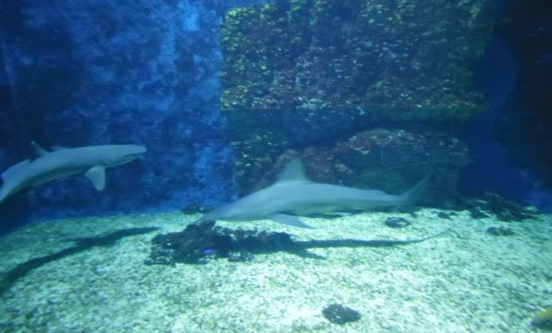
The sharks were amazing and frightening at the same time.

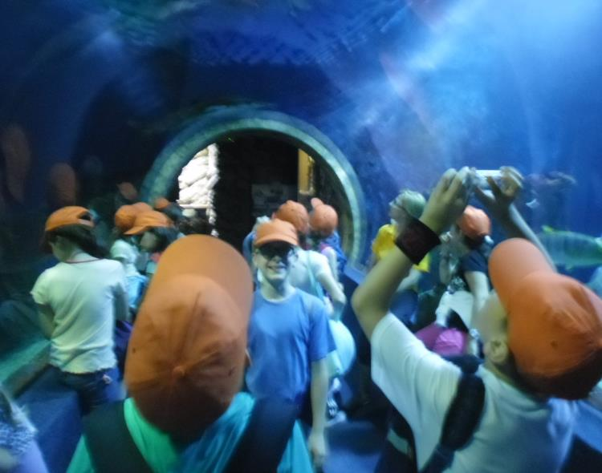
It was very exciting. The sharks were swimming over our heads.
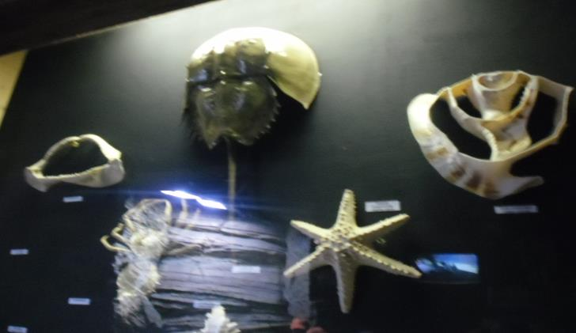
There were different kinds of shellfish. They were beautiful.
The next place was the Green Pyramid:
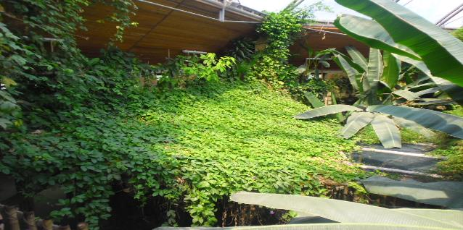

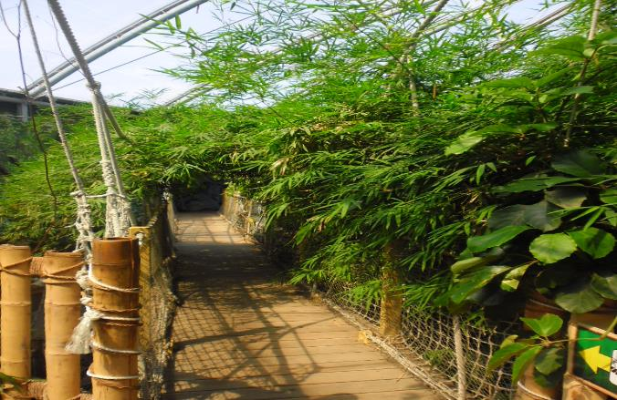
These pictures talk to themselves. Everything was green.
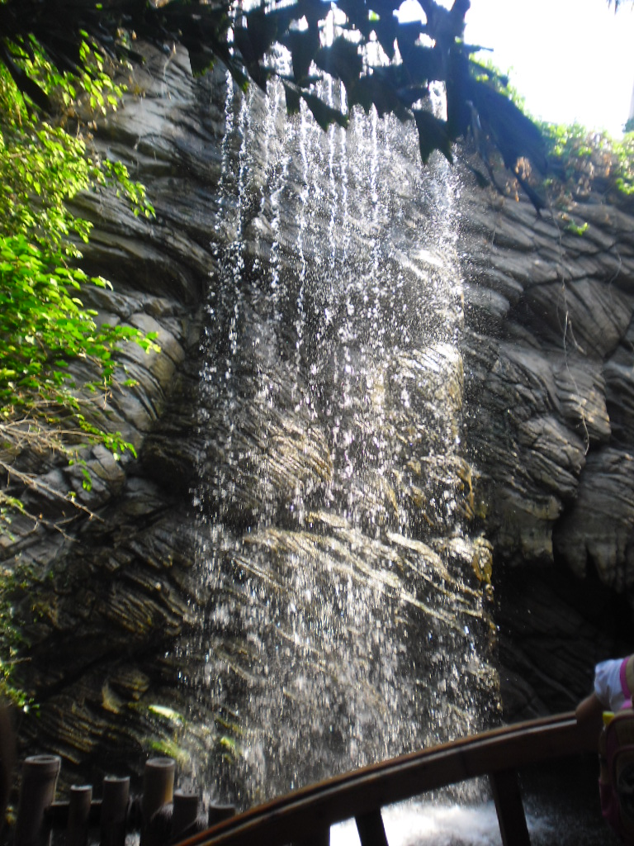

This was our favourite picture about this wonderful waterfall.

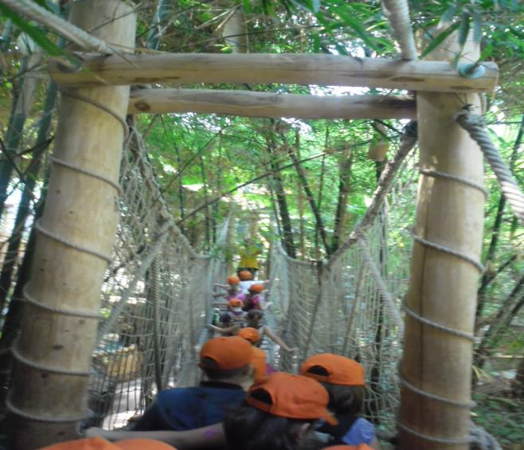

We had to concentrate but crossing was a challenge. It was moving while we were walking through. We were laughing a lot.
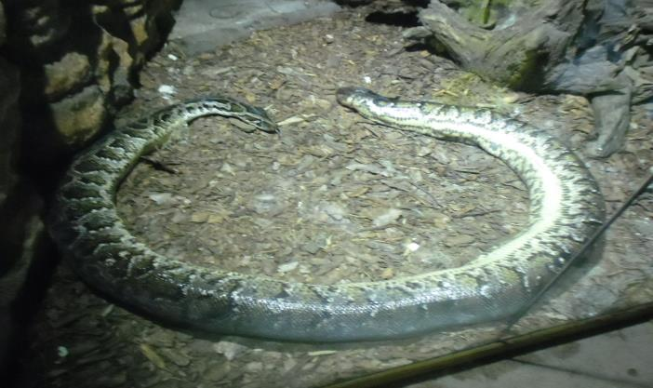

This snake threw its skin. Girls said ’Phew’ but boys said ’Wow’. However, it was huge.
Walking outside:
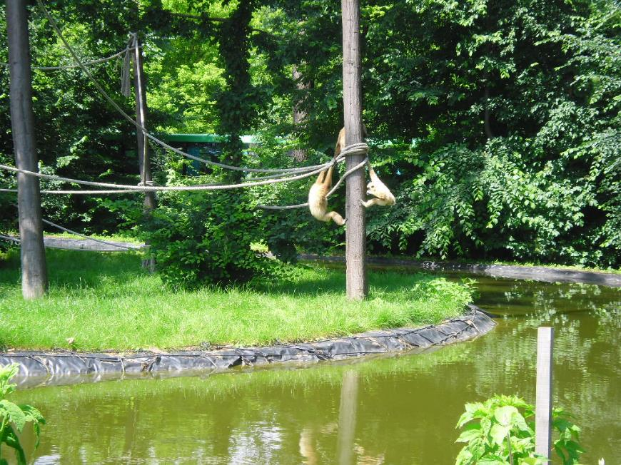
Monkeys were just hanging out and playing.
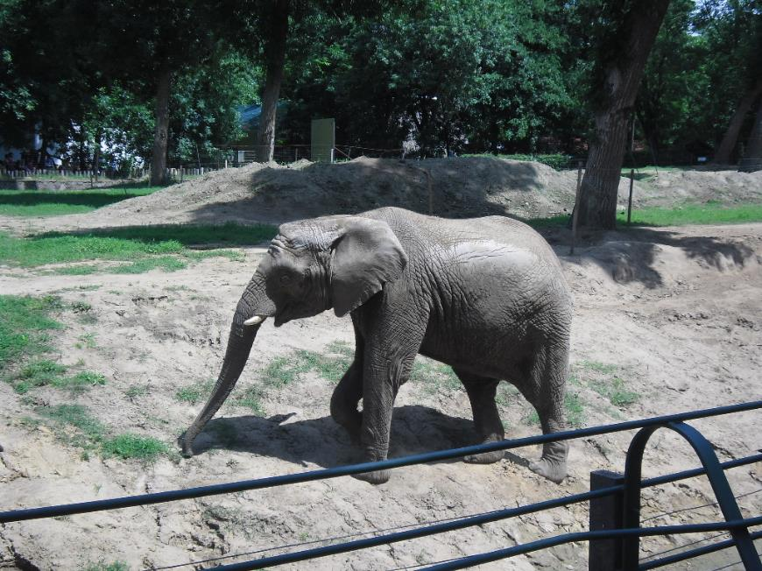
This is an African elephant called Szabolcs. It is a Hungarian boy’s name.
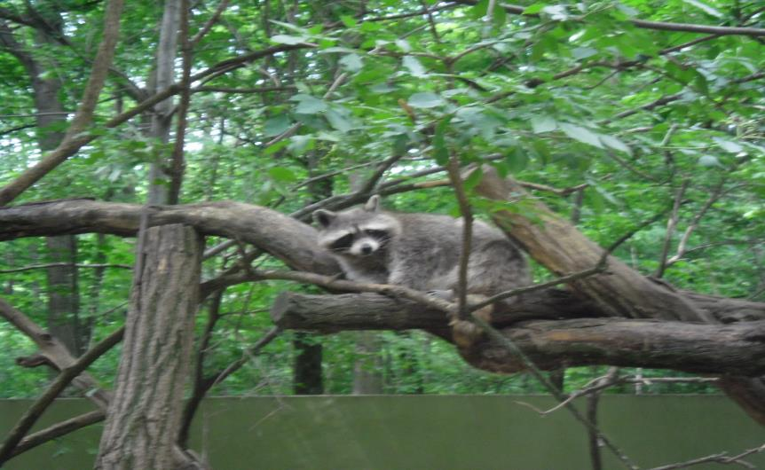
We learned about raccoons. They are known for their intelligence, for example they are able to remember the solution to tasks for up to three years. They are also very cute.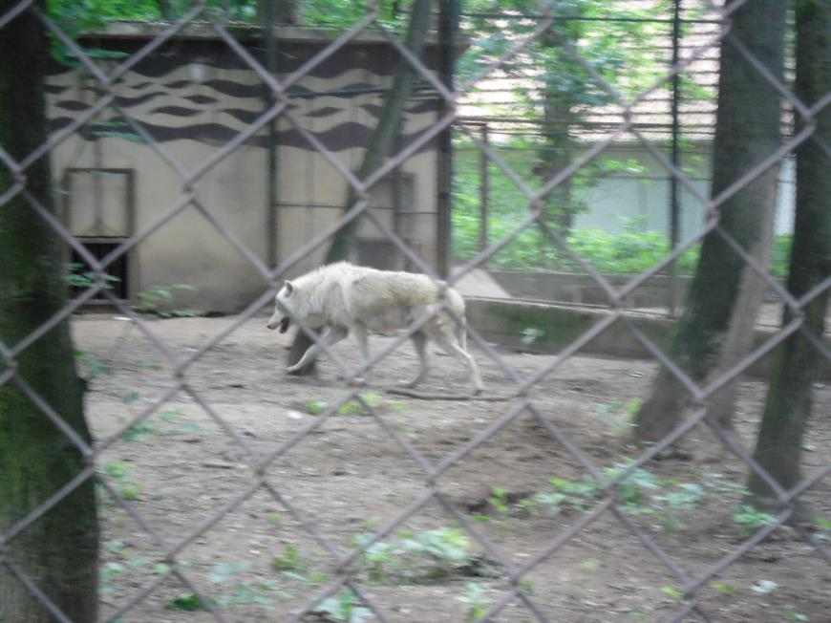
Dangerous and wild. We are talking about a wolf of course. There’s prestige in his walking, too.

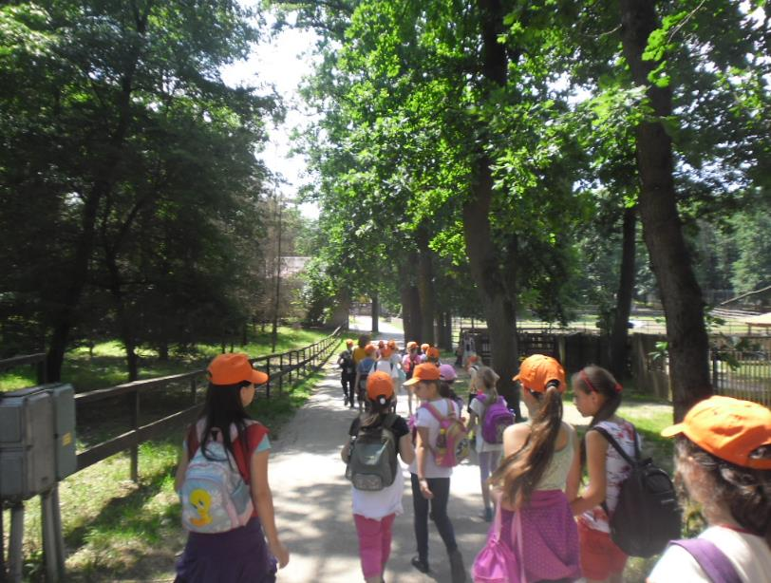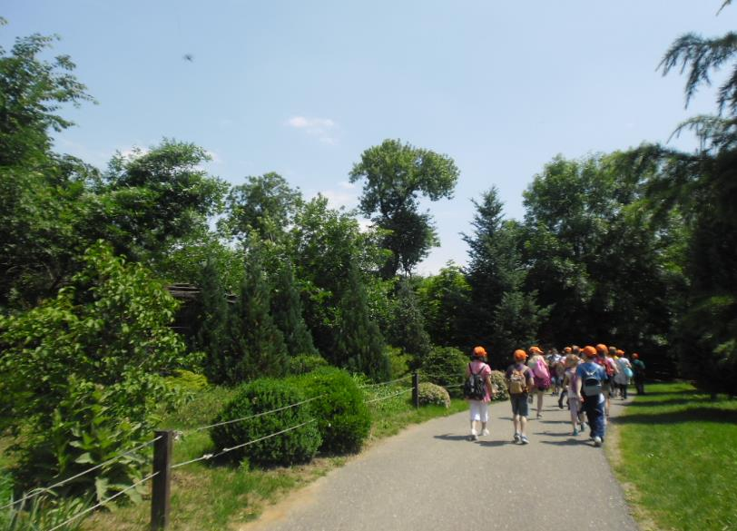
It was a long walk. We were a little bit tired but still enthusiastic.
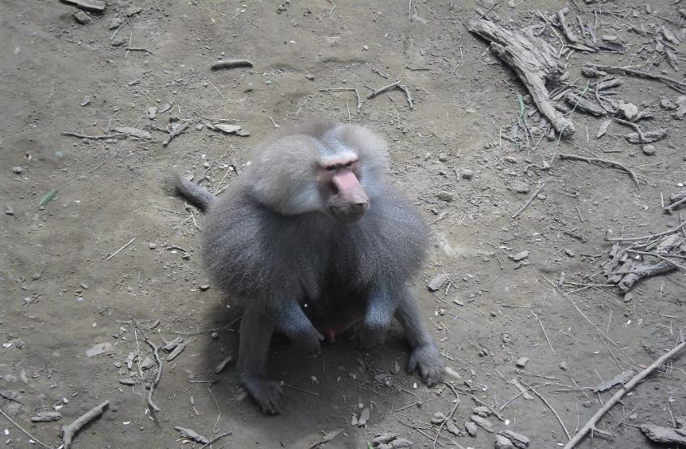
He seemed to be relaxed. He was staring at us, it was funny.
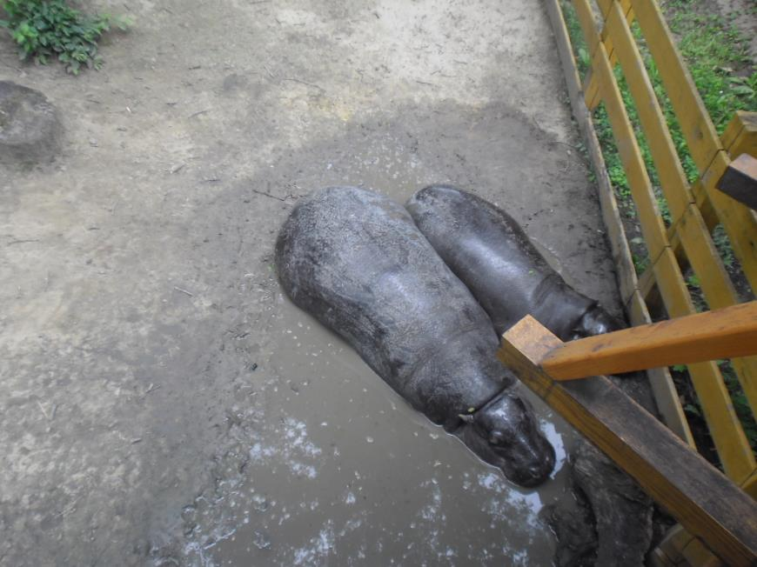
And if it is too hot, there’s always a refreshing puddle for those hippos.

And the dangerous ones. They’d rather be watched from a bigger distance:
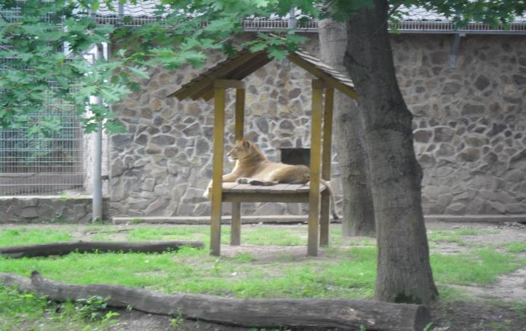
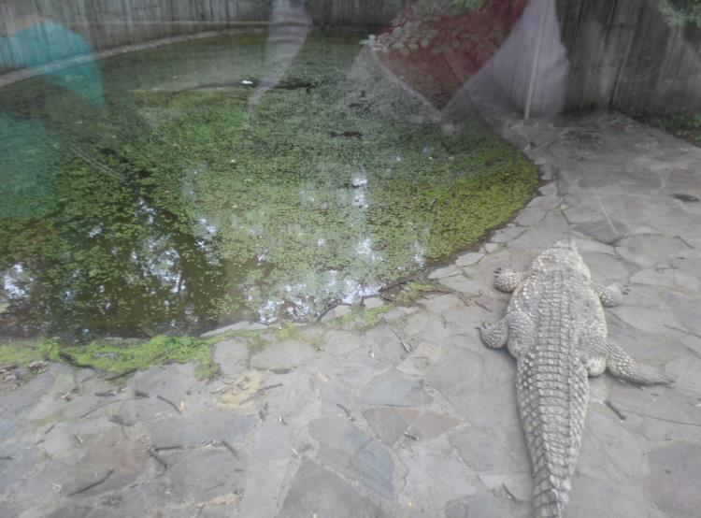
Let’s take a visit to Africa:
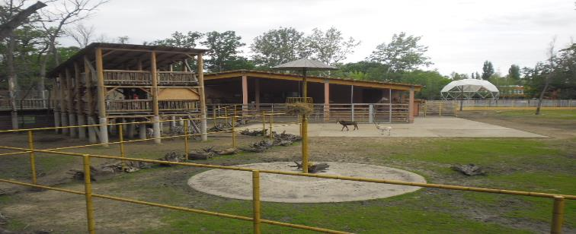
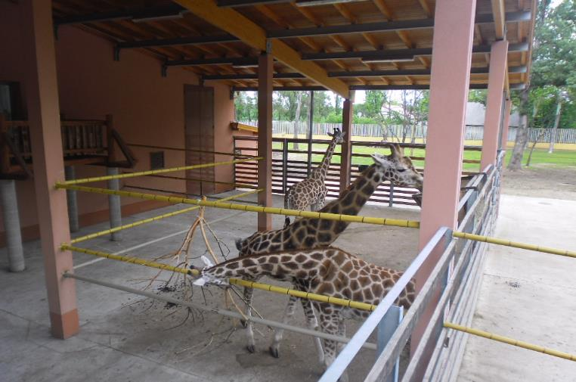
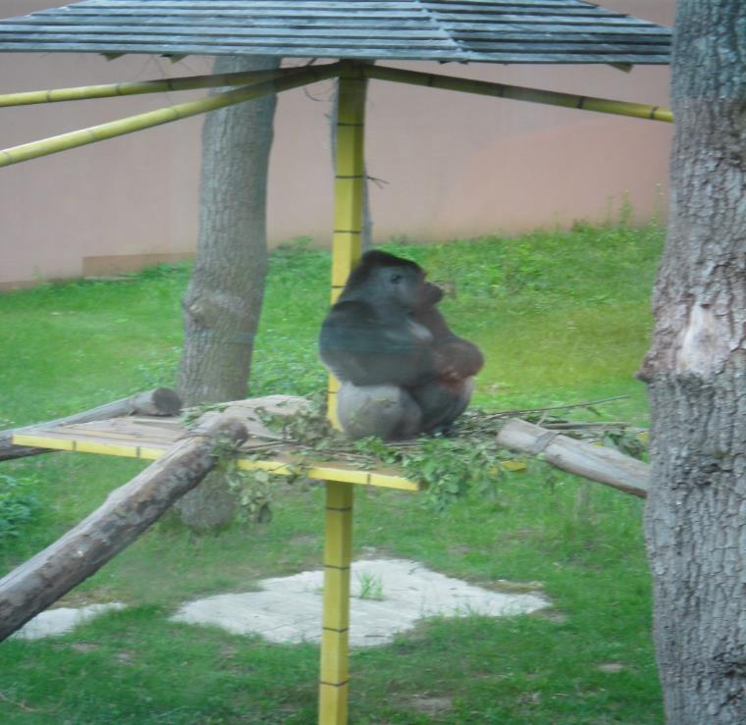

The most beautiful ones, the peacocks. We were lucky enough to see them in their whole beauty.
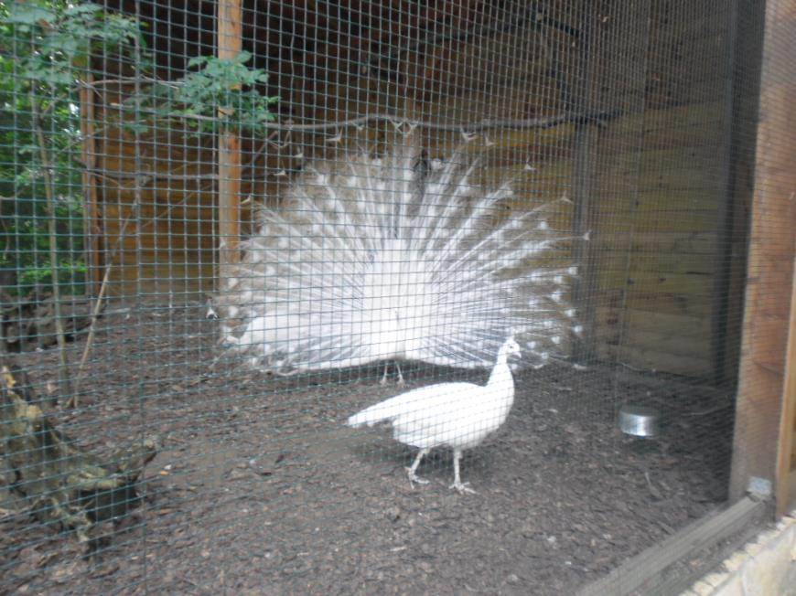
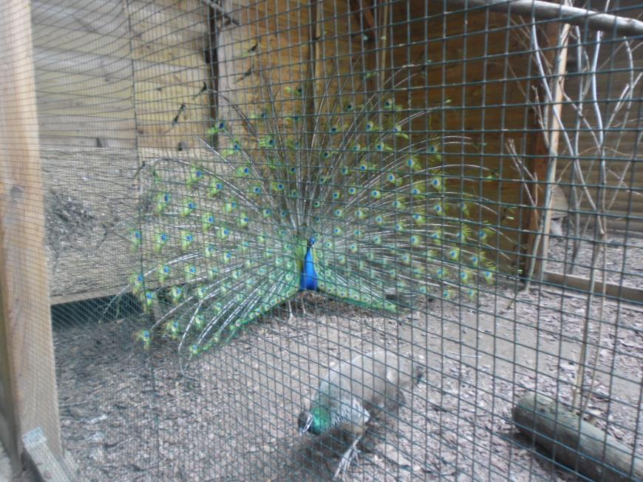

And finally, let’s see those animals which like cold and water:
First one, the penguins. They are very brave, they have no special fear of humans.
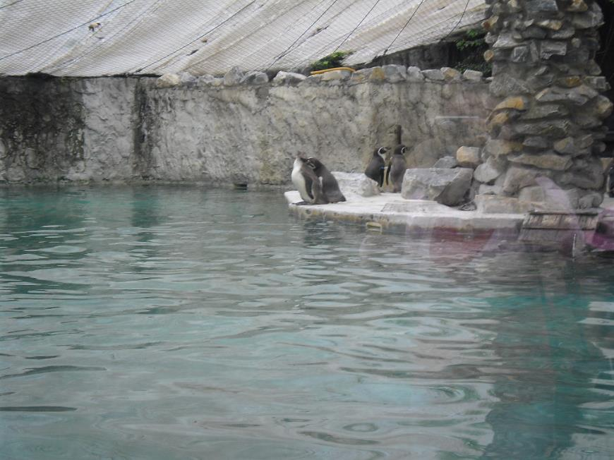
Next one is the polar bear. We think he was dreaming about a colder day.
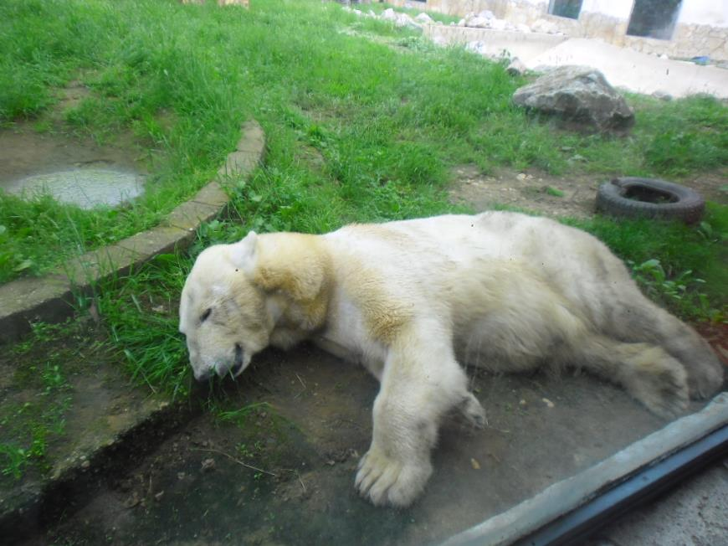
And finally, the seals. They were always moving inside the water and jumping out of it. Nevertheless, it was worth waiting for this picture.
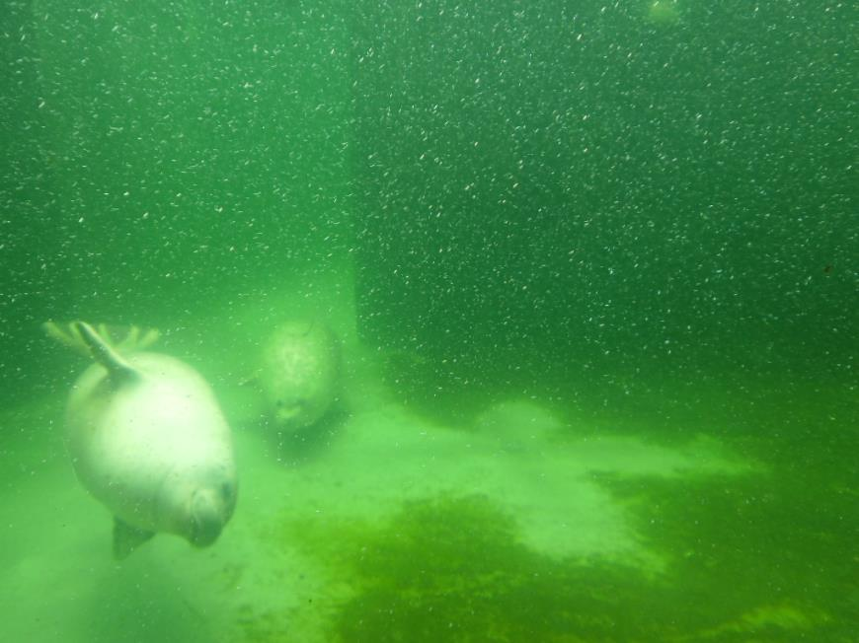
And it was the end of our amazing day. As you can see, we were so happy to get the chance for this amazing adventure.
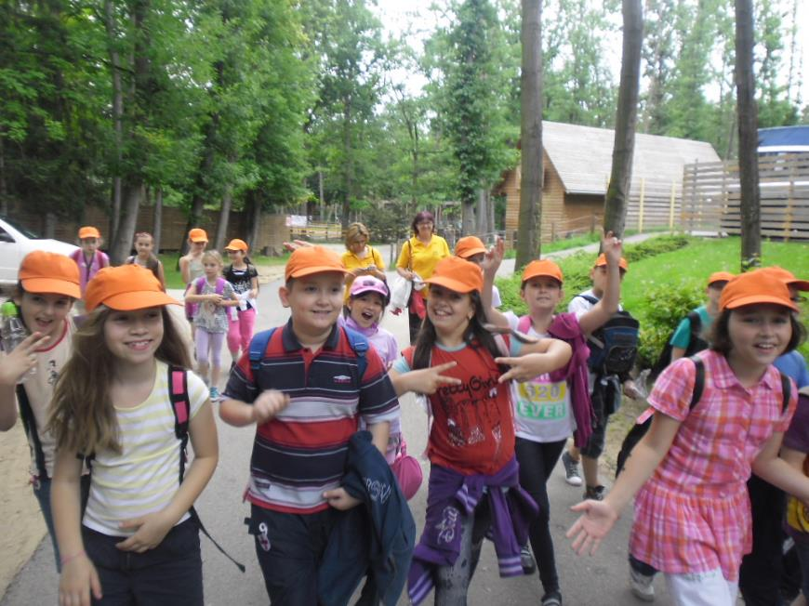
And we couldn’t miss a photo with that ’giraffe’ in front of the zoo. It was the best endig of this day.
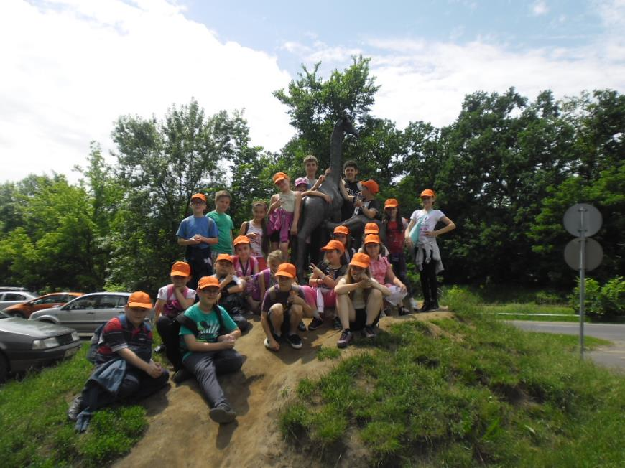

We also have a blog for our class. If you want to see our day in a video, click on the link below and enjoy it.
https://www.youtube.com/watch?feature=player_embedded&v=ezBpPS0HGSA

